EXPERIMENT LIST FOR PROGRAMMING ABILITY AND LOGIC BUILDING – 2
NAME : Krish panthri
BATCH : 2CSE8
ROLL NUMBER : 2410031338 WEEK : 19/1/26 - 25/1/26 LECTURE : 1

EXPERIMENT 1

You are given an array of integers arr[]. You have to reverse the given array. Note: Modify the array in place.
EXAMPLE
INPUT arr = [1, 4, 3, 2, 6, 5]OUTPUT[5, 6, 2, 3, 4, 1]Explanation: The
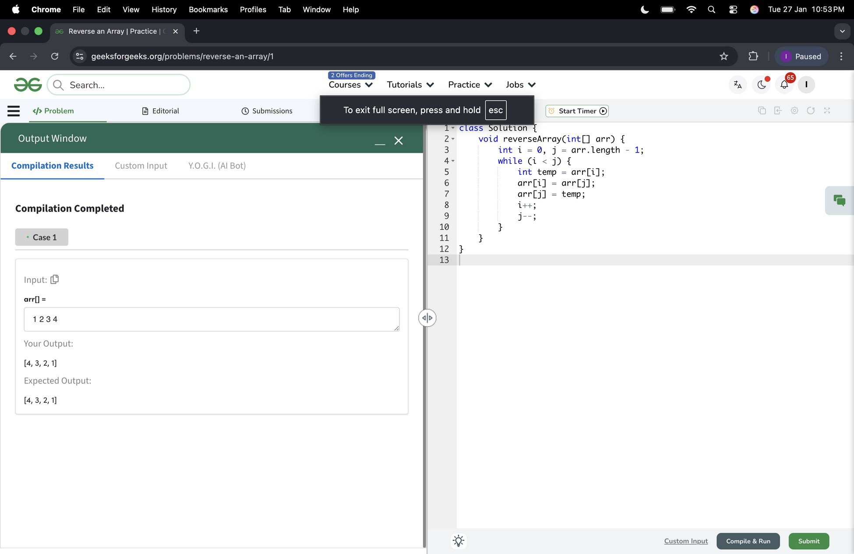
elements of the array are [1, 4, 3, 2, 6, 5]. After reversing the array, the first element goes to the last position, the second element goes to the second last position and so on. Hence, the answer is [5, 6, 2, 3, 4, 1].

EXPERIMENT 2

Given an array arr[]. Your task is to find the minimum and maximum elements in the array.

Examples:
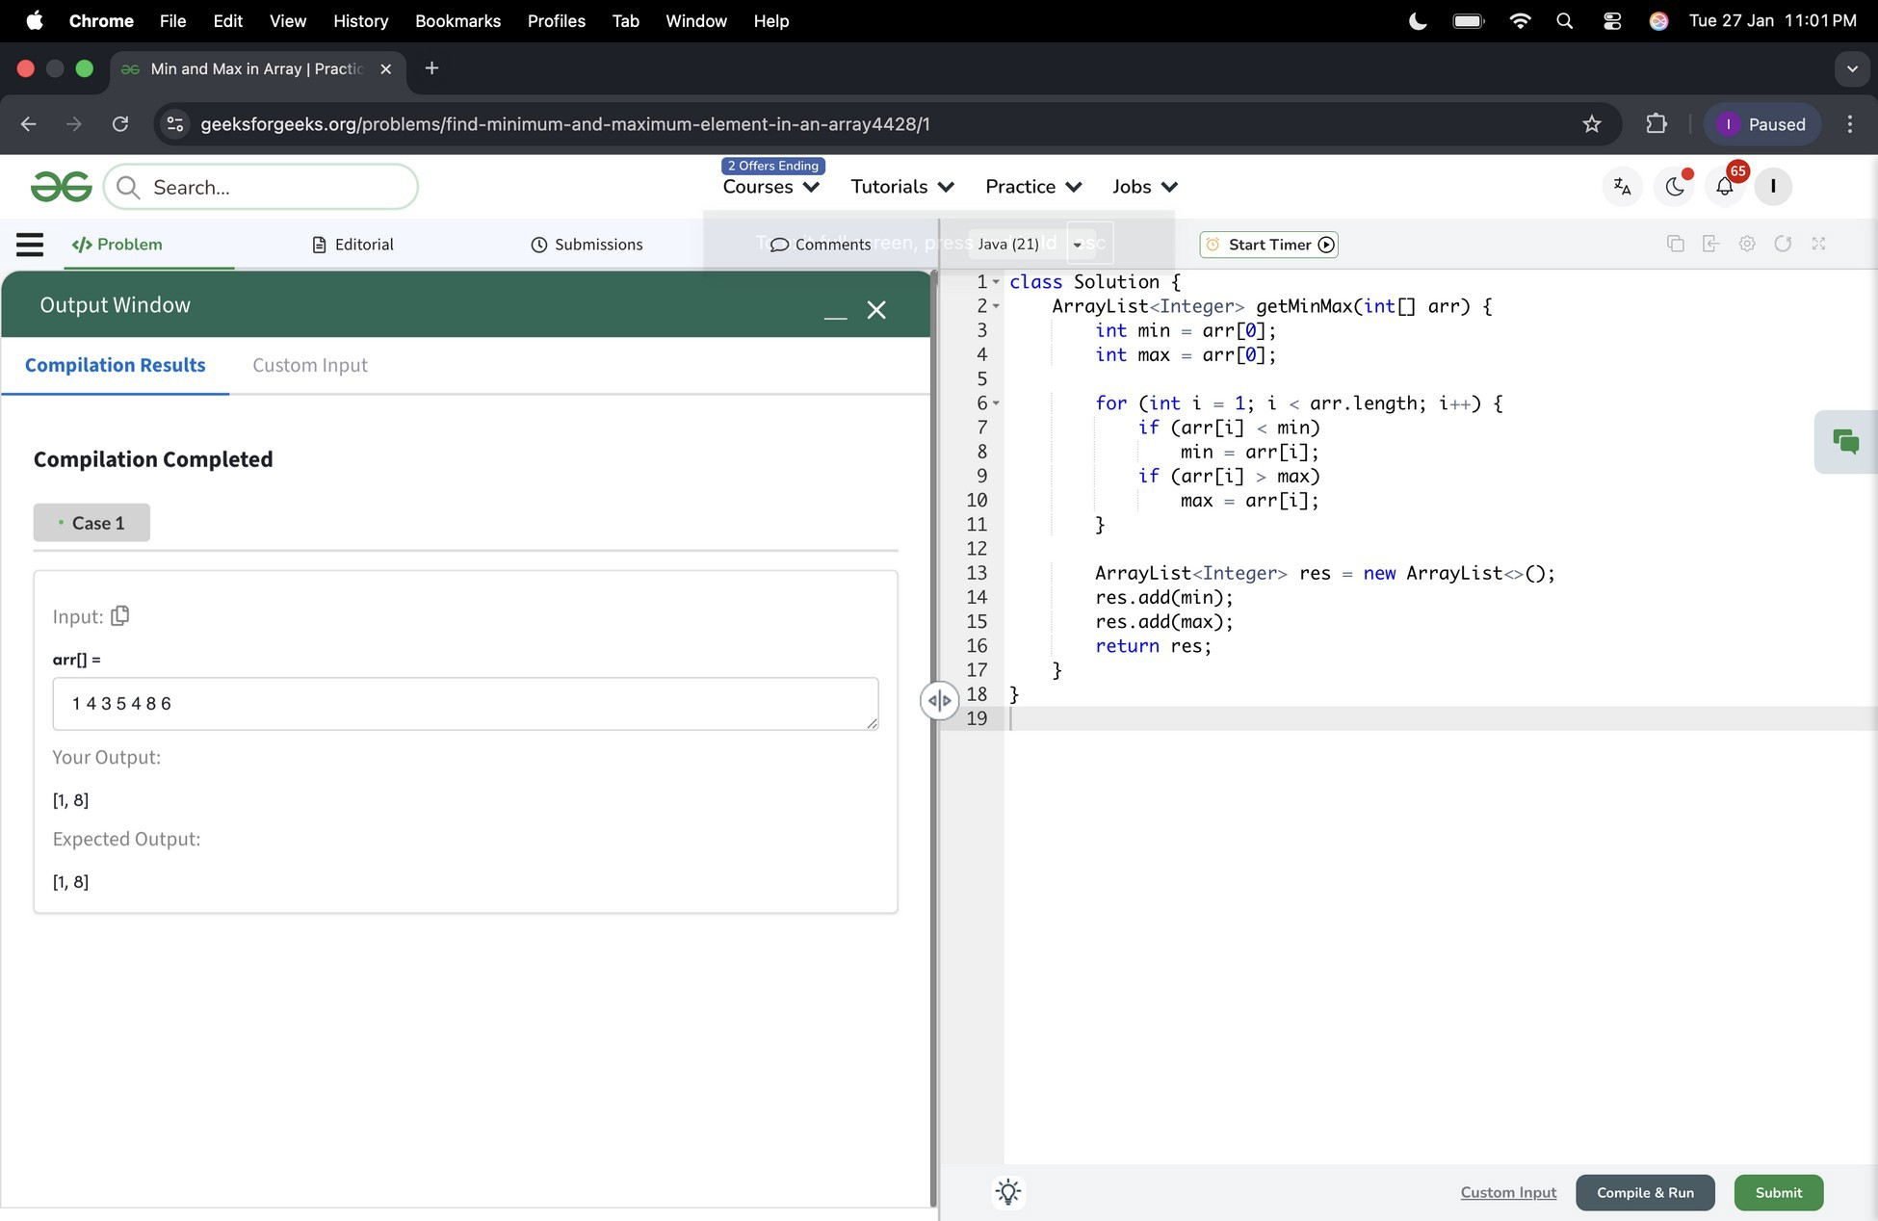
Input: arr[] = [1, 4, 3, 5, 8, 6]Output: [1, 8]Explanation: minimum and maximum elements of array are 1 and 8.

EXPERIMENT 3

Given an integer array arr[] and an integer k, your task is to find and return the kth smallest element in the given array.

Note: The kth smallest element is determined based on the sorted order of the array.

Examples :
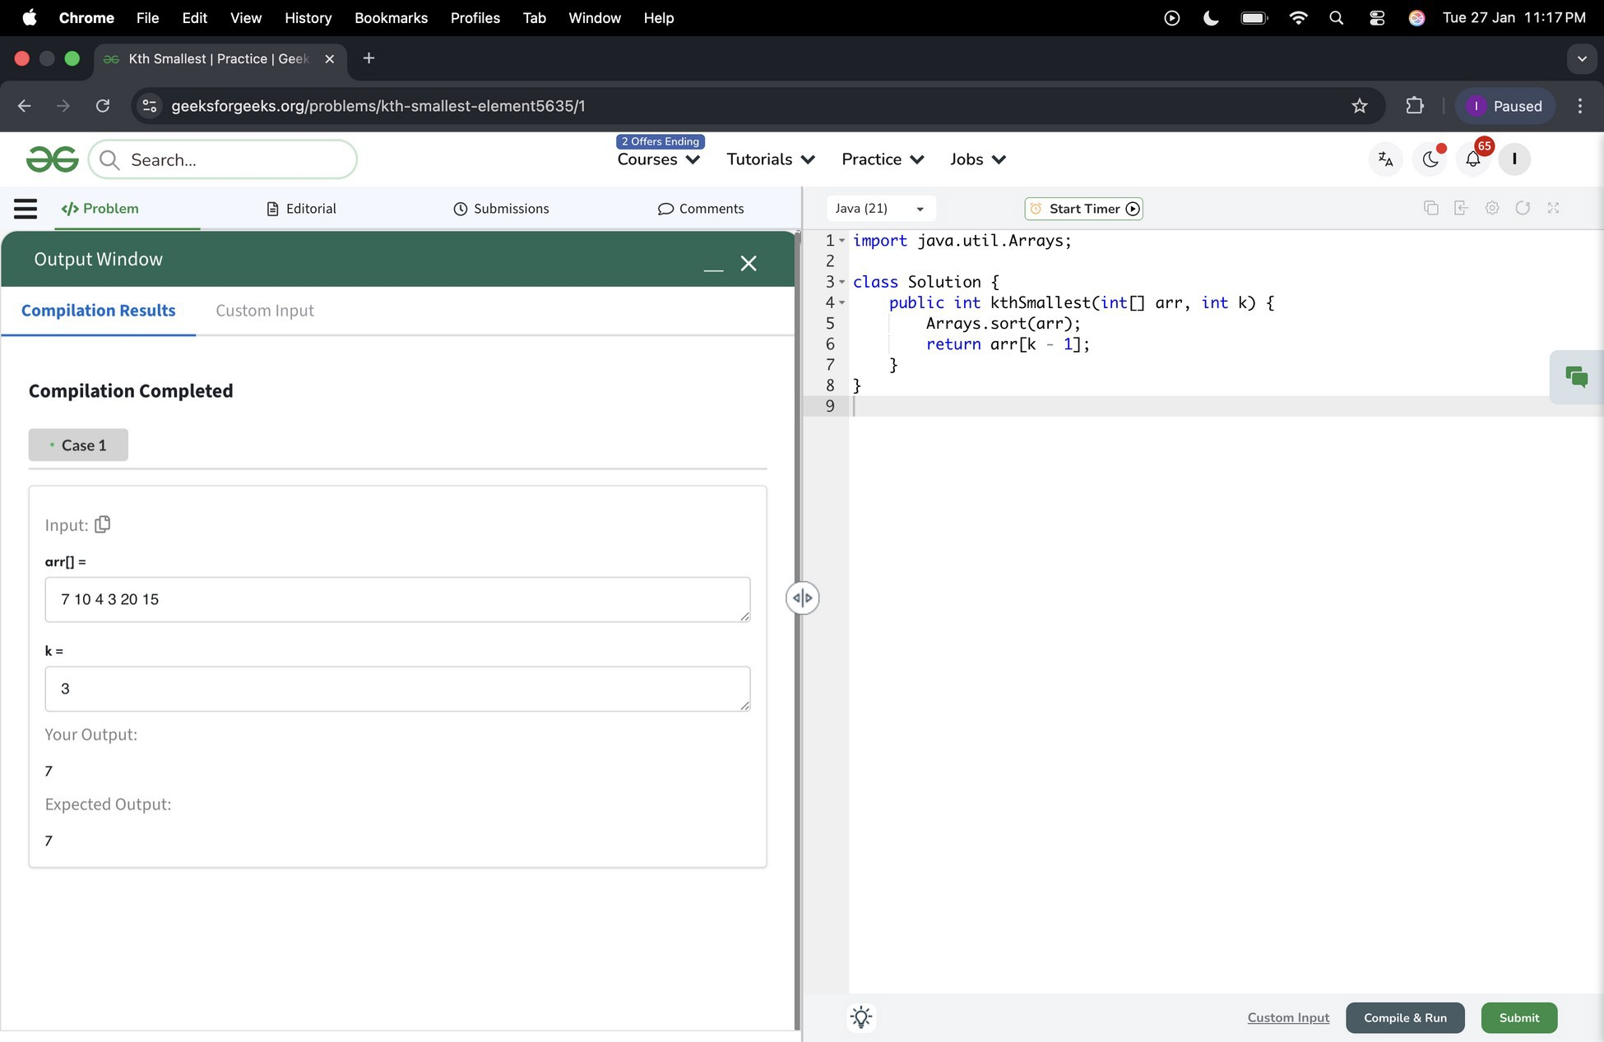
Input: arr[] = [10, 5, 4, 3, 48, 6, 2, 33, 53, 10], k = 4Output: 5Explanation: 4th smallest element in the given array is 5.

EXPERIMENT 4

You are given two arrays a[] and b[], return the Union of both the arrays in any order.

The Union of two arrays is a collection of all distinct elements present in either of the arrays. If an element appears more than once in one or both arrays, it should be included only once in the result.

Note: Elements of a[] and b[] are not necessarily distinct.Note that, You can return the Union in any order but the driver code will print the result in sorted order only.

Examples:
Input: a[] = [1, 2, 3, 2, 1], b[] = [3, 2, 2, 3, 3, 2]Output: [1, 2, 3]Explanation: Union set of both the arrays will be 1, 2 and 3.

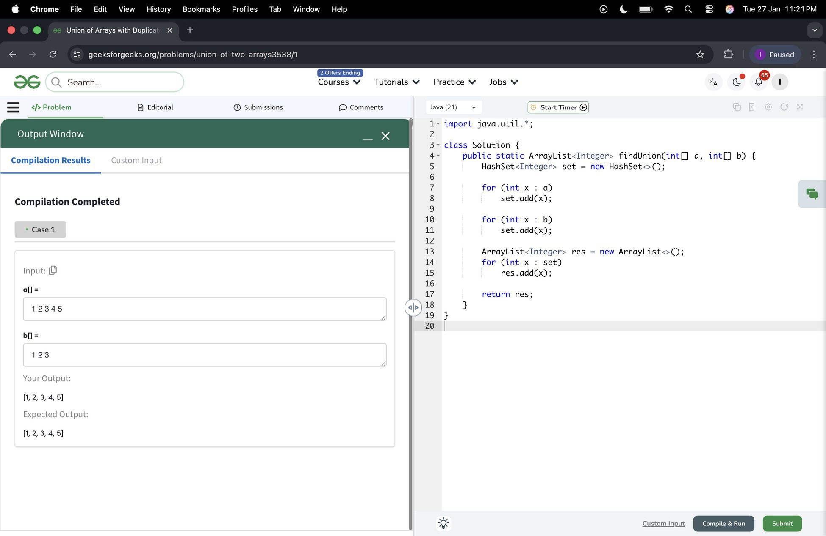

EXPERIMENT 5
Given an array arr[]. The task is to find the largest element and return it. Examples:
Input: arr[] = [1, 8, 7, 56, 90]Output: 90Explanation: The largest element of the given array is 90.

File Edit
II
Chrome
Window Help 0 6,,. - 9 0. � 0 Tue 27 Jan 11 23 PM

e e Largest in Array I Practice I x + v
Tab
Profiles
Bookmarks
History
View
f- C �O geeksforgeeks org/problems/largest-element-1n-array4009/Q?utm_source=youtube&utm_med1um=collab_str1ver_ytdescnpt1on&utm_campa1gn=largest-eleme * 0 1 Paused ;

-aG, Q Search...

Courses v Tutorials v Practice v Jobs v

= </>Problem � Editorial (!) Submissions DComments Java(21) I StartTimer0]
1 • class Solution {

Output Window _ X r
-

Compilation Results Custom Input

Compilation Completed

- Case1

Input: (0
orrl)=

1875690

Your Output:

90
Expected Output:

90
2 • publi.c i.nt largest(i.nt[J arr) {
3 i.nt max = arr[0];
4· for (i.nt i. = 1; i. < arr.length; i.++) {
5 if (arr[i] > max)
6 max = arr[i.J;
7
8 return max;
9
10
11

Customln� Miiiidl♦ 1111

